Observation Sources
Observations can be loaded into VStar from a variety of sources. Out of the box, observations can be loaded from the AAVSO International Database (AID) or files conforming to one of two formats (described in the Load from File section).

Observations from other sources (e.g. other AAVSO sources, Kepler, SuperWASP, ASAS) can be loaded via plug-ins found in the AAVSO Plug-in Library (http://www.aavso.org/vstar-plugin-library).

Load from AID
To load a set of observations from the AID, ensure you are connected to the Internet, then select New Star from AAVSO Database... from the File menu or click the button at the left of the toolbar.

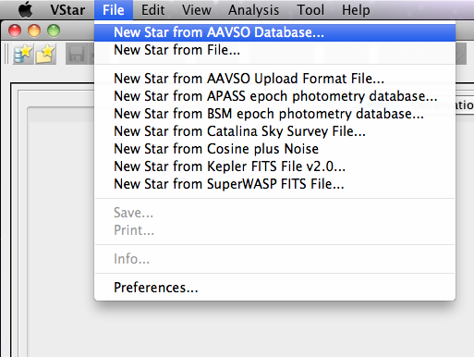

The following dialog will appear:
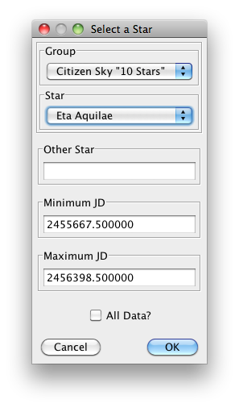
If a name or AAVSO Unique ID (AUID) of a variable star is entered into the Other Star text box, this will be used instead of the currently selected object in the Star drop-down. The Citizen Sky group (see the Group drop-down) contains all stars from the “10 star” tutorial. Other groups can be created via the Preferences dialog.

Either a Julian Date range must be specified or all data requested. This determines the time range over which data should be loaded.

If the requested object does not exist or there is no data for the object in AID or for the specified date range, a message box will appear to that effect, otherwise the available data will be loaded, the light curve plot, observation list, and mean series created. If visual or V band data exists, corresponding observations will be initially visible; this can subsequently be changed via the Plot Control Dialog (see View menu). Otherwise, the band with the most observations will be displayed initially.

Load from File
To load observations from an AAVSO download format file or “simple” file, select the New Star from File... menu item from the File menu or click the second-to-left-most button in the toolbar.

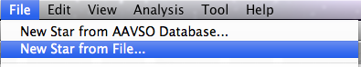

Files must conform to one of two formats:

- AAVSO download format
  - http://www.aavso.org/data-download
  - http://www.aavso.org/format-data-file

- Simple format, consisting of lines of the form:

Julian Date,Magnitude[,Uncertainty][,Observer Code][,Validation Flag]
or simply:
Julian Date,Magnitude

In both cases, lines can either be comma or tab separated. Observations of other kinds can be loaded via observation source plug-ins. See the AAVSO plug-in library for more.

Selecting this menu item invokes the following file chooser:

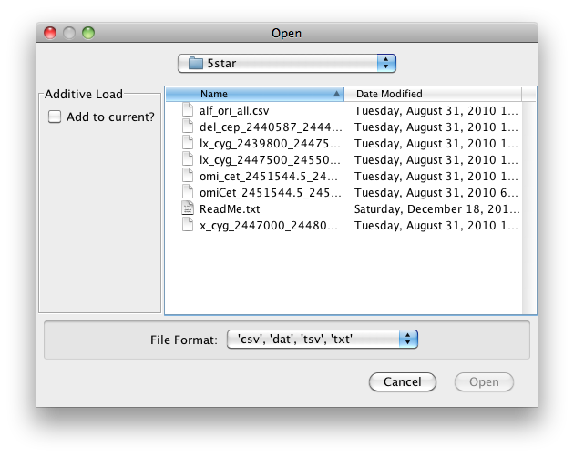
Selecting a conformant file and clicking the Open button will load the observations, leading to the same result as a Load from AID operation. If the file is not of a suitable format, an error dialog will be displayed.

Some observation source plug-ins may be able to accept a URL (Uniform Resource Locator or web page address) instead of a file to read observations from. In such cases, the dialog will have a Request URL button as follows:
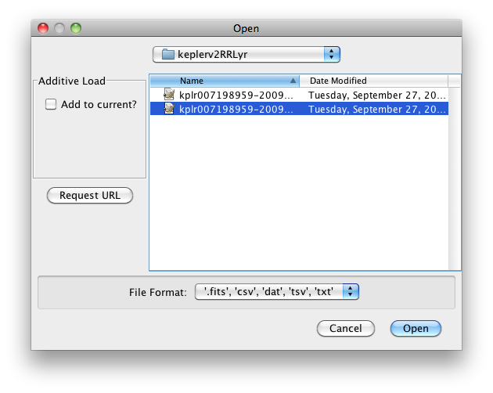

Selecting the button will yield this dialog:

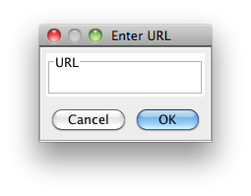

Some observation source plug-ins may only accept a URL as input in which case just the Enter URL dialog will be presented to the user.

This file dialog above also shows that observation source plug-ins may return additional file extensions, aiding in file list filtering in the file chooser.

Additive Loads
If the Add to current? checkbox is selected in the file chooser, the loaded observations will be added to any already loaded, irrespective the object. In this way, observations from different sources can be combined in a single VStar session. AID load is currently not additive, but this restriction is likely to be lifted in future.

If the newly loaded observations use Heliocentric Julian Dates (HJD), the previously loaded observations will be converted to use HJD or vice versa. If the first data set loaded is from the AID, the object’s Right Ascension (RA) and Declination (Dec) necessary for the HJD conversion is taken from VSX. In other cases, dialogs permit the entry of the RA and Dec for non-AID loads, such as this one (both RA and Dec currently assume B1950.0 rather than J2000.0 epoch):
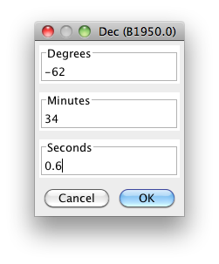
Further, AAVSO Upload Format files (used for the online WebObs tool; see AAVSO Plug-in Library) and ASAS are currently the only supported observation source that can contain explicit HJD observations, so the data must be loaded from AID and then from one of these file types for HJD conversion to occur. If HJD conversion takes place for a given additive load, a dialog will inform the user of this.

